Eclipse IDE Setup

1. Eclipse installation
2. Create java project
3. Resolving the leakage error

Click the below link to download Eclipse IDE

<https://www.eclipse.org/downloads/>

Click on DOWNLOAD X86_64

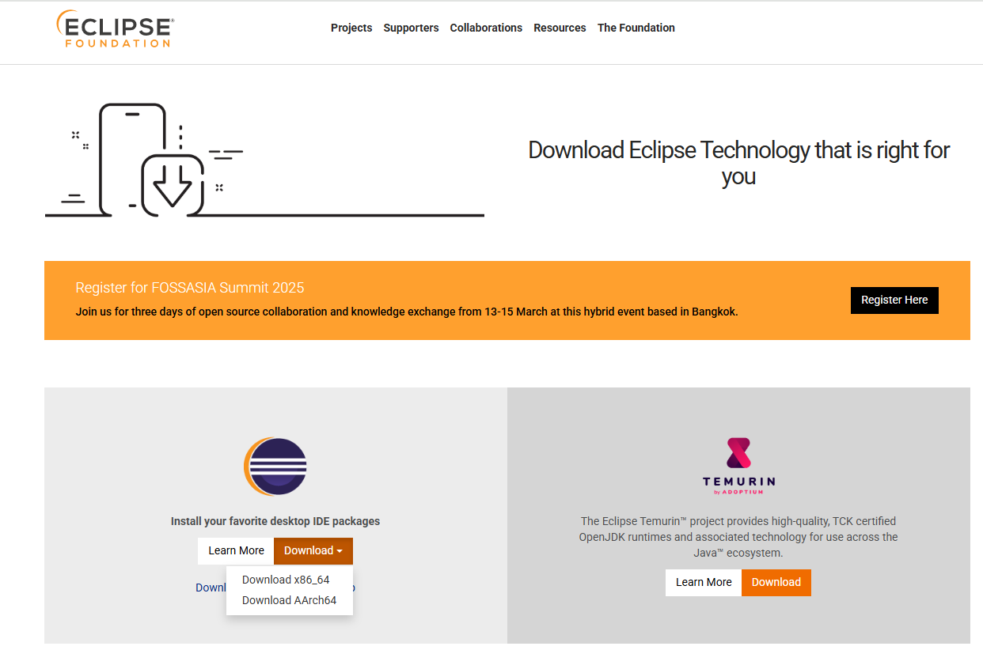

Once install the IDE need to select “**JAVA FOR DEVELOPER”**

Creating java project

Click on file=> New=> Java Project

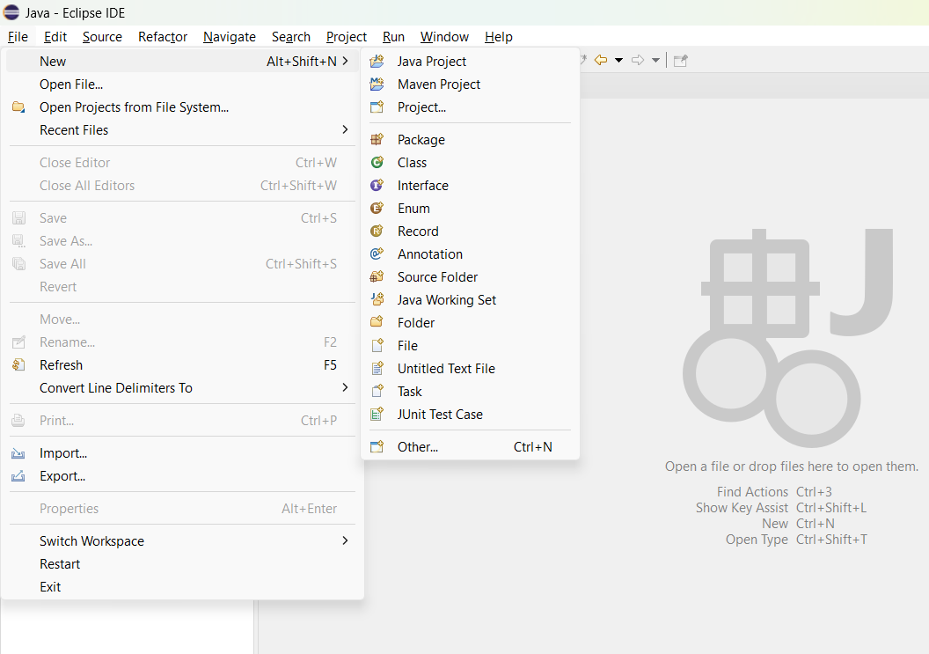

1. Enter your project Name
2. Uncheck use default location if you want to change location (try to avoid save project in C:)
3. Use JRE as javaSE-17 / as per your installed java version
4. Uncheck Create module-info.java file then finish.

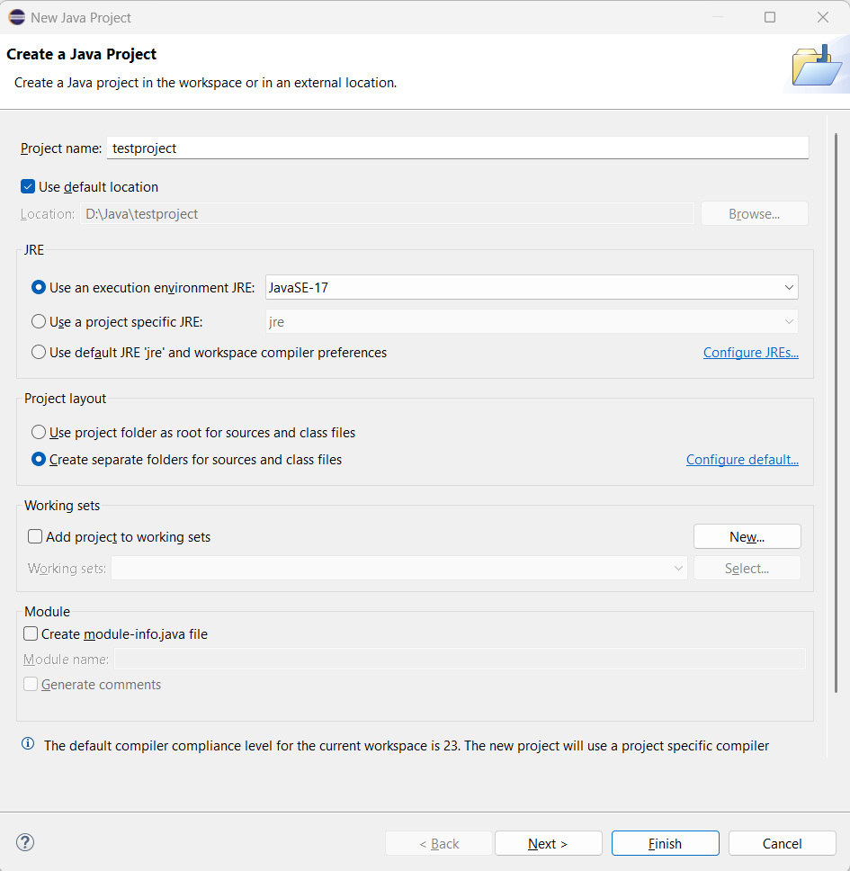

4

3

2

1

You will find the project here.

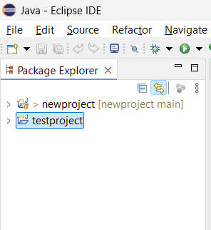

To add class right click testprojct file => new => class

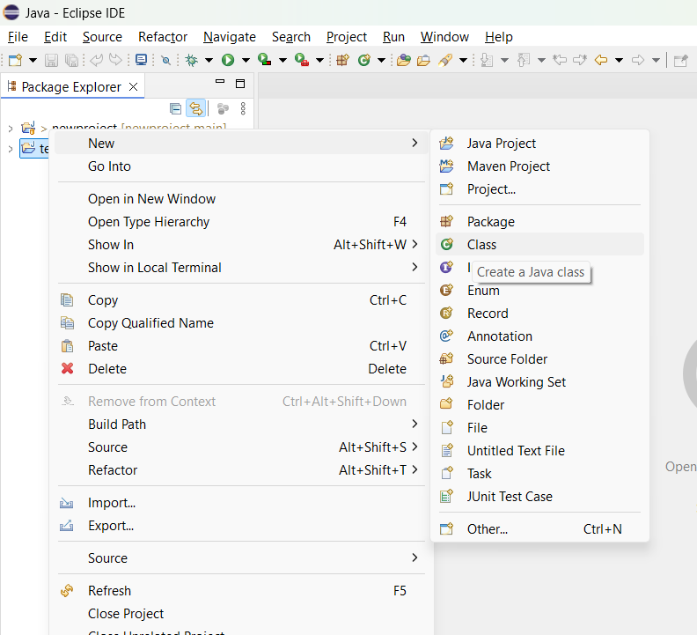

1

You will get below pop

1. Enter package name followed by com.
2. Enter class using camel case
3. Click on public static void main (string[] args)
4. Click on finish

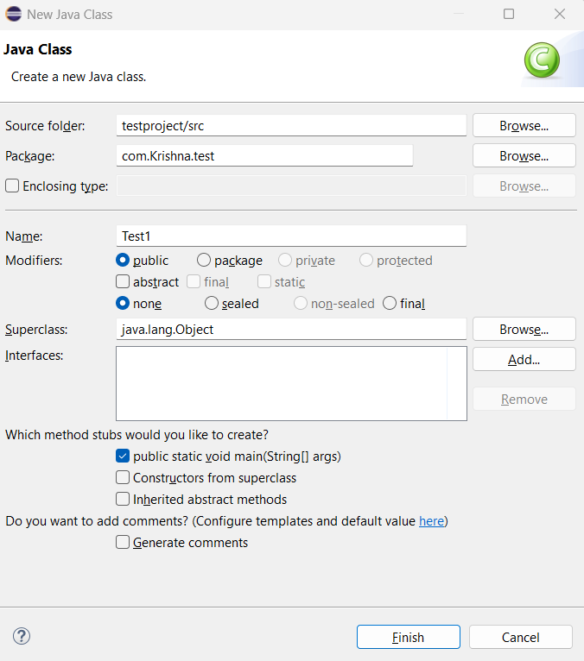

You will get below default code

Once done with your code click on run

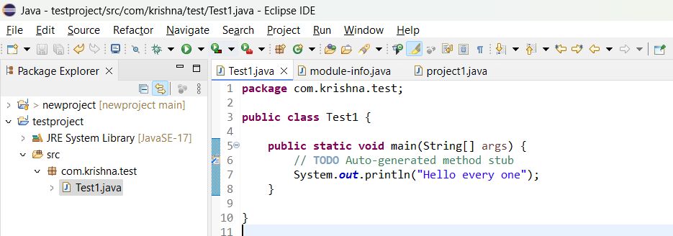

Your will output will be shown in console tab

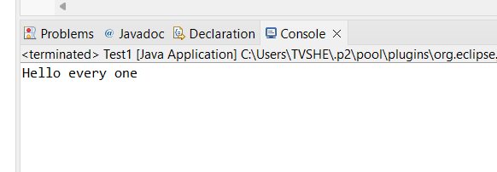

If you get leakage error

Right click on src => properties

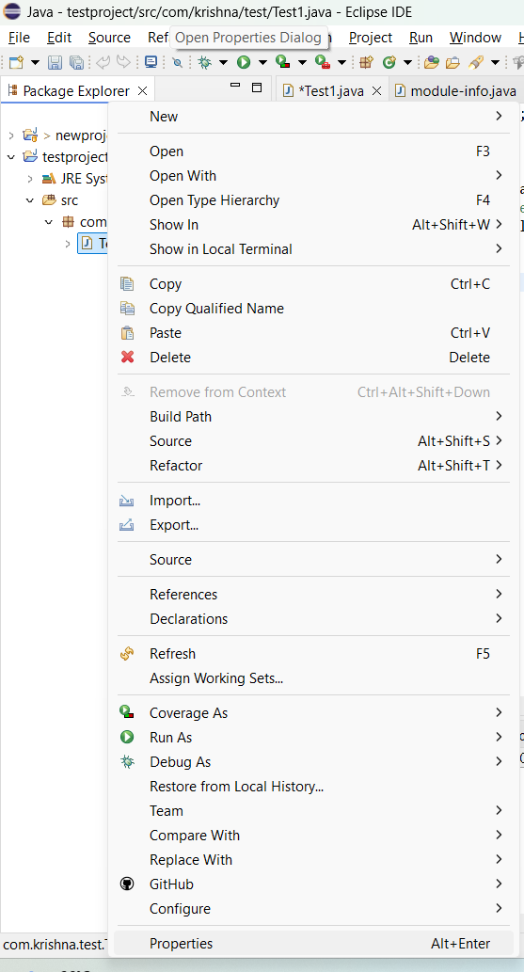

1. Click java compiler
2. Un check the box
3. Change the compiler version to installed java version
4. Click on apply and close

Then re-run the program.

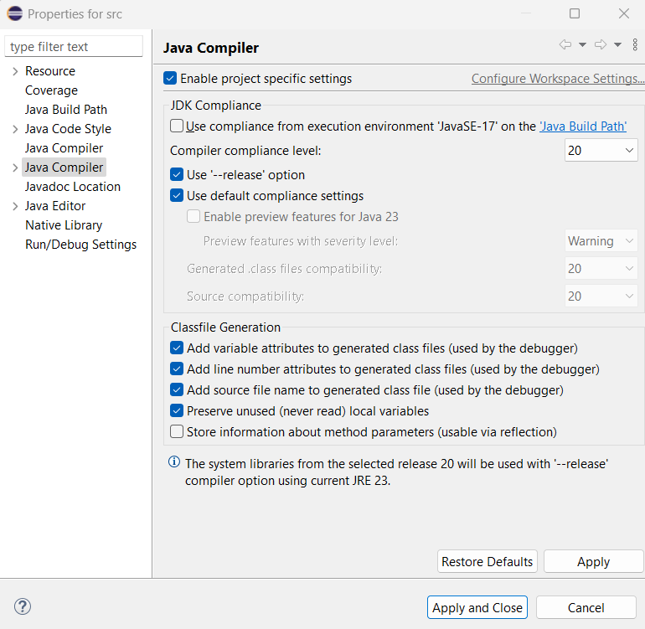

4

3

2

1